Applecross Senior High School

Western Australian Certificate of Education
Semester One Examination, 2018

Question/Answer Booklet
 | Total | Result | _____%
Section One | 53
Section Two | 97
Total | 150
MATHEMATICS
SPECIALIST
UNIT 1

Section One:
Calculator- free

Student’s Name: _______________________________________
As shown on your exam timetable

Student’s Teacher Mrs Waddell

Time allowed for this section
Reading time before commencing work: five minutes
Working time for this section: fifty minutes

Materials required/recommended for this section
To be provided by the supervisor
This question /Answer Booklet
Formula Sheet

To be provided by the candidate
Standard Items: pens (blue/black preferred), pencils (including coloured), sharpener,
correction fluid/tape, eraser, ruler, highlighters.
Special items: nil.

Important note to candidates
No other items may be taken into the examination room. It is your responsibility to ensure
that you do not have any unauthorized notes or other items of a non-personal nature in the
examination room. If you have any unauthorized material with you, hand it to the supervisor
before reading any further.

Section | Number of questions available | Number of questions to be answered |  | Working time (minutes) | Marks available | Percentage of exam
Section One:  Calculator-free | 8 | 8 |  | 50 | 53 | 35
Section Two:  Calculator-assumed | 13 | 13 |  | 100 | 97 | 65
 |  |  | Total |  | 150 | 100

Instructions to candidates

- The rules for the conduct of examinations are detailed in the School Examination Rules provided with your exam timetable. Sitting this examination implies that you agree to abide by these rules.

- Write your answers in this Question/Answer Booklet.

- You must be careful to confine your responses to the specific questions asked and to follow any instructions that are specific to a particular question.

- Spare pages are included at the end of this booklet. They can be used for planning your responses and/or as additional space if required to continue an answer.
- Planning: If you use the spare pages for planning, indicate this clearly at the top of the page.
- Continuing an answer: If you need to use the space to continue an answer, indicate in the original answer space where the answer is continued, i.e. give the page number. Fill in the number of the question(s) that you are continuing to answer at the top of the page.

- Show all your working clearly. Your working should be in sufficient detail to allow your answers to be checked readily and for marks to be awarded for reasoning. Incorrect answers given without supporting reasoning cannot be allocated any marks. For any question or part question worth more than two marks, valid working or justification is required to receive full marks. If you repeat an answer to any question, ensure that you cancel the answer you do not wish to have marked.

- It is recommended that you do not use pencil, except in diagrams.

- The formula sheet and your notes are not to be handed in with your Question/Answer Booklet.

Section One: Calculator-free 35% (53 Marks)
This section has eight (8) questions. Answer all questions. Write your answers in the spaces provided.

Working time: 50 minutes.

Question 1 (5 marks)
Relative to the origin $O$, points $A$ and $B$ have position vectors $-3i-2j$ and $i-4j$ respectively.

(a) Determine the unit vector $\hat{c}$, where $c=\vec{AB}$. (3 marks)

(b) Vector $d$ has magnitude $3\sqrt{5}$, is parallel to $c$ and in the opposite direction. Determine $d$.
(2 marks)

Question 2 (5 marks)
Let the displacement vectors $a, b$ and $c$ be $(11, -4)$, $(5, 14)$ and $(8, m)$ respectively, where $m$ is a constant.

(a) Determine the vector $3a+2b$. (2 marks)

(b) Given that $\left|a+b+kc\right|=0$, detemine the values of $k$ and $m$. (3 marks)

Question 3 (8 marks)
Consider the following statement about a simple (no edges that cross) polygon:

If it has an interior angle sum of 360°, then it is a square.

(a) Use a counter-example to explain why the statement is false. (2 marks)

(b) Write the converse statement and state whether it is always, sometimes or never true.
(2 marks)

(c) Write the inverse statement and state whether it is always, sometimes or never true.
(2 marks)

(d) Write the contrapositive statement and state whether it is always, sometimes or never true.
(2 marks)

Question 4 (6 marks)
(a) Determine the value of the constant $n$, given that the vectors $12i+nj$ and $5i-8j$ are perpendicular. (2 marks)

(b) The vectors $a$ and $b$ are such that $\left|a\right|=18, \left|b\right|=12$ and $a∙b=-33$. Evaluate

(i) $-2a∙3b$. (1 mark)

(ii) $\left(a+b\right)∙(b-a)$. (3 marks)

Question 5 (7 marks)
(a) In the diagram below, the vertices of triangle $ABC$ lie on a circle with centre $O$. Given that $∠ABC=54°$, determine the values of $∠AOC$ and $∠OAC$. (2 marks)

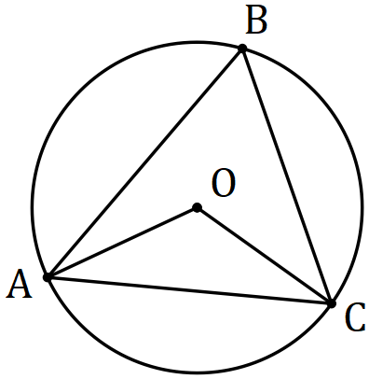

(b) The two tangents through a point P exterior to a circle touch it at the points B and D. The chord BD subtends an angle of 130 degrees at a point C on the circumference of the circle as shown below. Determine the angle $x$ between the two tangents. (5 marks)

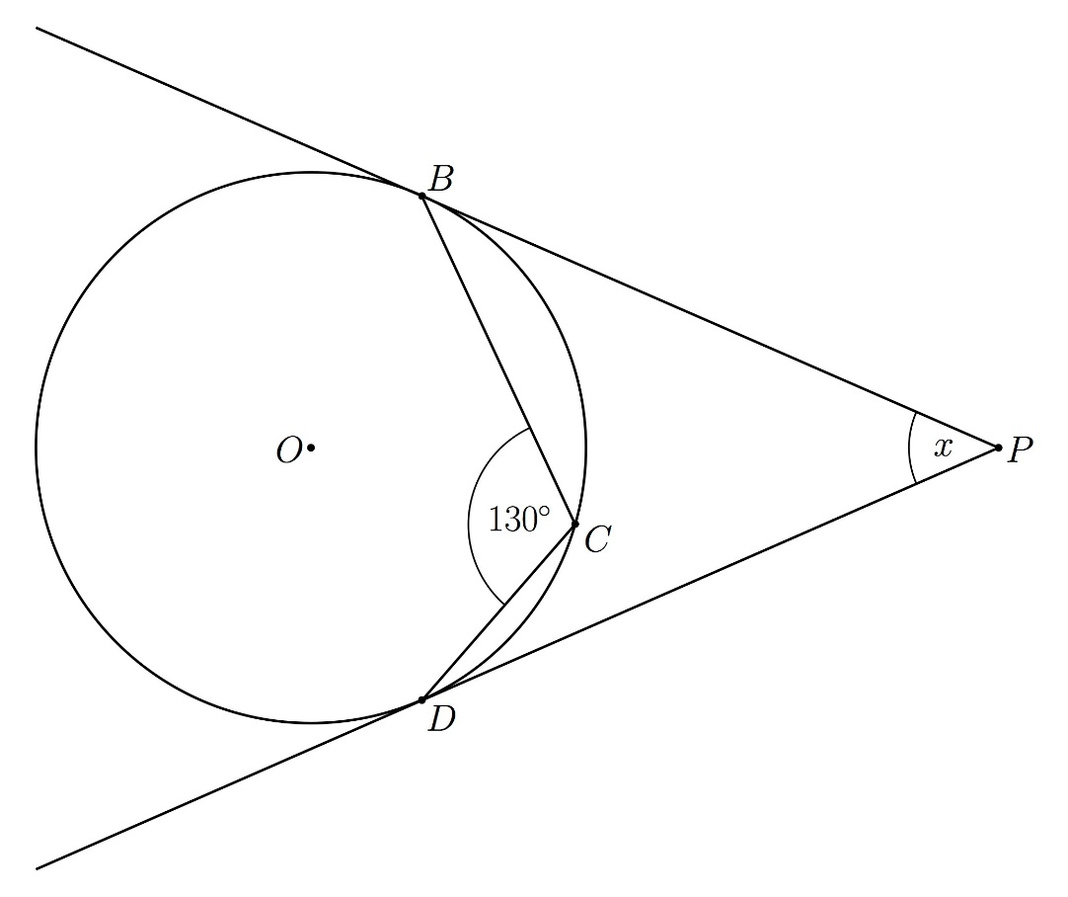

Question 6 (6 marks)
A drone leaves point $P$ and travels $115$ m on bearing of $340°$ to $Q$, then $30$ m on bearing $070°$ to $R$ and finally $85$ m on bearing $160°$ to $S$.

(a) Sketch a neat diagram to show the path of the drone. (2 marks)

(b) The drone is to return directly from $S$ to $P$. Determine the distance it must fly and on what bearing. (4 marks)

Question 7 (9 marks)
(a) Evaluate $^{16}P_{11}÷ ^{14}P_{11}$. (3 marks)

(b) Express $9!+8!+7!$ in the form $a^{2}b!$, where $a$ and $b$ are positive integers. (3 marks)

(c) Show that for $n∈Z, n≥3$, the sum $n!+\left(n-1\right)!+\left(n-2\right)!$can always be expressed in the form $a^{2}b!$ where $a$ and $b$ are positive integers. (3 marks)

Question 8 (7 marks)
In the diagram below, two chords of a circle, $BC$ and $DE$, intersect at $F$. $GB$ is perpendicular to $BC$ at $B$ and $GE$ is perpendicular to $DE$ at $E$. The line $GF$ intersects chord $CD$ at $H$.

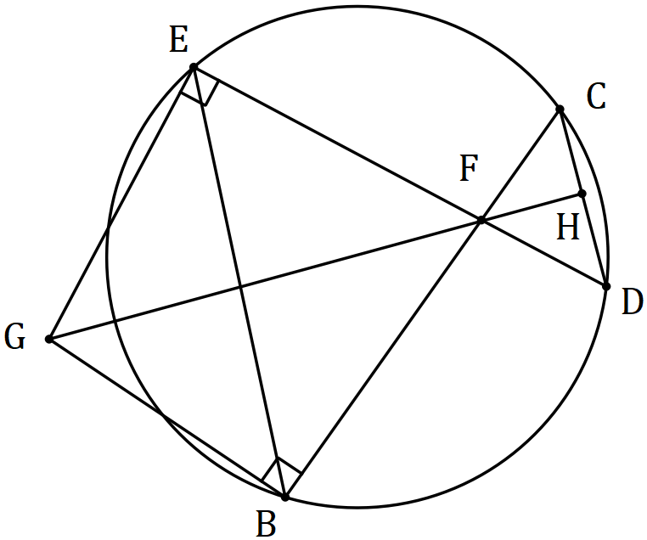

(a) Explain why $GEFB$ is a cyclic quadrilateral. (1 mark)

(b) Prove that $∠CDE=∠EGF$. (3 marks)

(c) Prove that $GH$ is perpendicular to $CD$. (3 marks)

Additional working space.

Question Number: _________

Additional working space.

Question Number _________

